# Project Part 1: Creating a Business Program in C++

04/02/2018 Section: 23060

Skating Monkey Software LLC

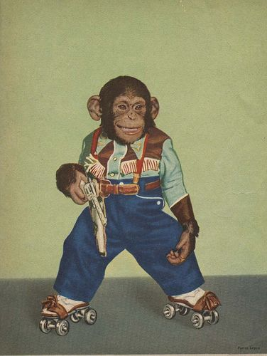 Mariah Belcher – Business Analyst II

Sean Crews – Software Technician

## Miyagi car wash control program

The Miyagi car wash control program outlined below is designed to provide menu driven control to automated and hand car wash owner/operators allowing multi-dimensional data processing capabilities in a customer centric user interface. Spoon

The Miyagi software package presents car wash options in a simple menu driven format that, not only internally calculates, but also records car wash profits. In addition, Miyagi supplies business data, to include: the type of car wash, the value of the car wash, and the name and number of the employee performing the work. All of this information is conveniently stored for accounting purposes and output to the customers’ receipt. Spoon

In order to achieve the maximum wax on, wax off throughput, Miyagi software automates and simplifies the front end business processes, reducing employee workload and streamlining the customer experience. Developed by a business analyst with multiple years of experience in C++ programming, our platform has been fully assessed by a software technician with a proven track record of destructive testing of both software and operating systems and has been vetted by an independent consultant with a PHD in Information Technology specializing in cyber security. Spoon

Miyagi car wash control software: Simple, reliable, profitable, and safe. Spoon

## Miyagi car wash control program

Pseudocode:

* Start
* request user input: car wash type
  + Standard – Function: calculate total
  + Wash and wax – Function: calculate total
  + Full detail – Function: calculate total
  + Exit - exit confirmation message
* Send input (car wash) to receipt (text file)
* Send totals to receipt (text file)
* request user input: employee choice from two dimensional array
  + Hideo
  + Vanya
  + Giuseppe
  + Burhan
  + Sam
* Send input (employee choice) to receipt (text file)
* Send employee name to receipt (text file)
* Print receipt (text file)
* Copy text file data to vector file for record keeping
* end



Start



Ask user to choose

car wash type



Case car wash

type



3

.

Full detail



4

.

Exit



2

.

wash wax



1

.

wash



Function calc

total amount



Function calc

total amount



Function calc

total amount



Display You did

not choose a

valid option



Read input into

receipt



Input total into

receipt



Page

2



Ask user to

choose

employee



Array employee



1

.

Hideo



2

.

Vanya



3

.

Guiseppe



4

.

Burhan



5

.

Sam



Copy receipt

to vector file



Page

1



End



Input employee into

receipt



Print Receipt